SFM using Colmap

Autonomous Drones Lab, Tel-Aviv University

Buildots

Yehonathan Mandel

Patrick Marciano

3rd March 2020

Last update: 17th March 2020

Index

Index 1

General: 2

Settings: 2

The experiments: 2

29/12/19: 3

05/01/20: 5

10/01/20: 6

13/01/20: 7

20/01/20: 8

23/01/20: 11

30/01/20: 12

Conclusion: 14

Test example: 15

Reproducing the experiments: 15

# 

# General:

This document will present a step by step solution for executing sfm using Colmap. An exemple will run with videos gathered from Buildots (cfr. “Test exemple”). This document will also present all the test that were performed, their results and conclusions.

# Settings:

**Camera:**

Model: Garmin Virb 360

Firmware version:

**Server:**

OS/Arch: linux/amd64

Distribution: Ubuntu 18.04.1 LTS (GNU/Linux 4.15.0-88-generic x86_64)

CPU: Intel(R) Xeon(R) Silver 4110 CPU @ 2.10GHz

Cores: 16

**Docker:**

Version: 18.09.2

API version: 1.39

**Colmap version:** 3.5

# The experiments:

Summary:

* **29/12/19:** 20 experiments testing frame size, camera stitching distances, camera models
* **05/01/20:** 4 experiments at 10 FPS, near stitching setting, double circled path at 1000px and 2000px for FOV and SIMPLE_RADIAL_FISHEYE camera models.
* **10/01/20:** 10 experiments: 5 at 10 FPS and 5 at 20 FPS over the 5 camera models used previously. 1 extra experiment was conducted with buildots’s extraction and calibration script (30 FPS and 1000X504px frames)
* **13/01/20:** Using buildots calibration, 3 experiments at 1000 px frames for 3 camera models. 3 experiments at 2000px frames for the same 3 camera models
* **20/01/20:** 5K and 5.7K test for 10 and 20 FPS
* **23/01/20:** Frames stabilization for 5K and 5.7K 10FPS
* **30/01/20:** Frames stabilization using Garmin VIRB edit, multi-room test, 5 FPS test.

## 29/12/19:

1. 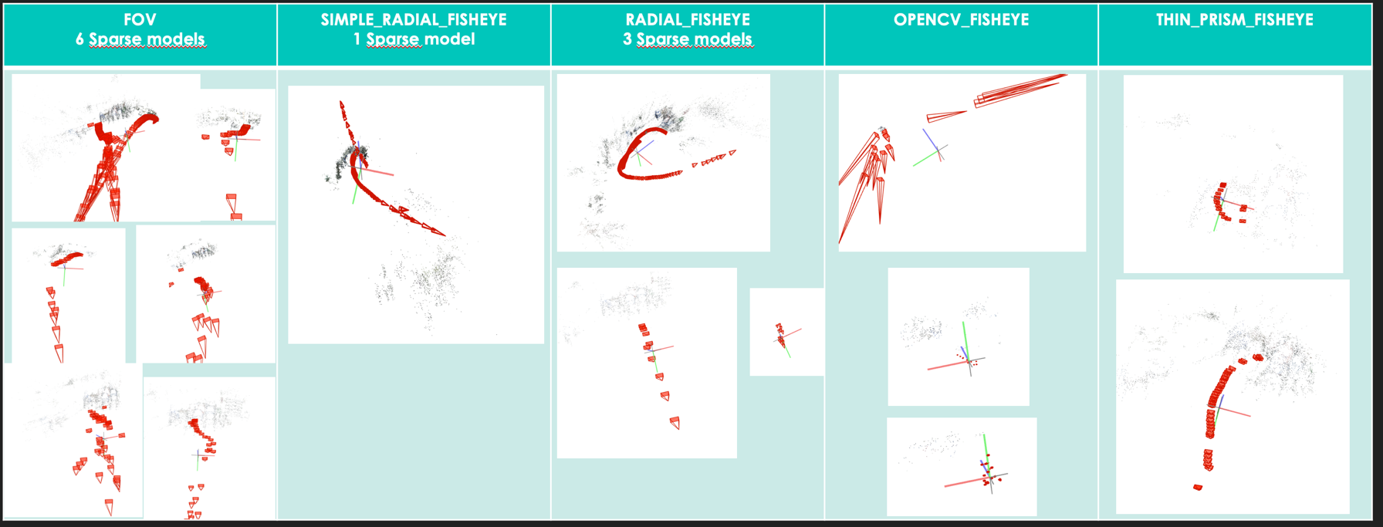Near stitching, 1000px wide frames:
2. 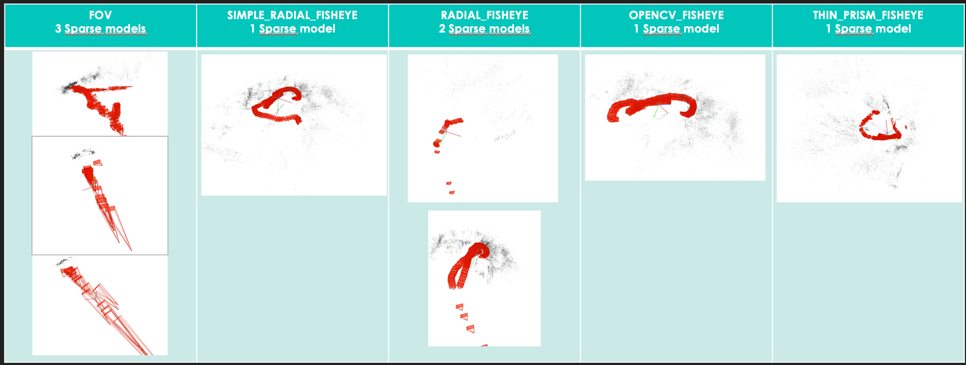Near stitching, 2000px wide frames:
3. 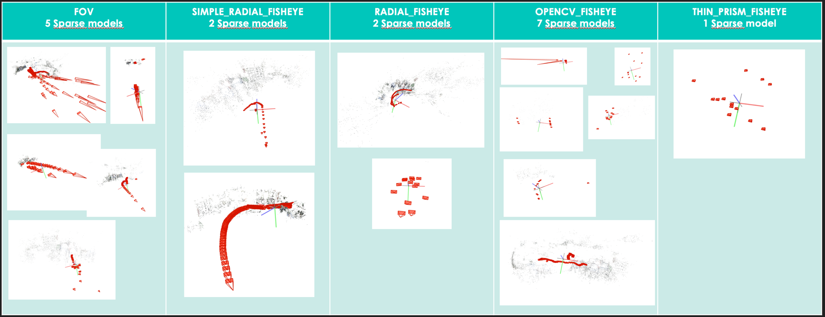Far stitching, 1000px wide frames:
4. Far stitching, 2000px wide frames:

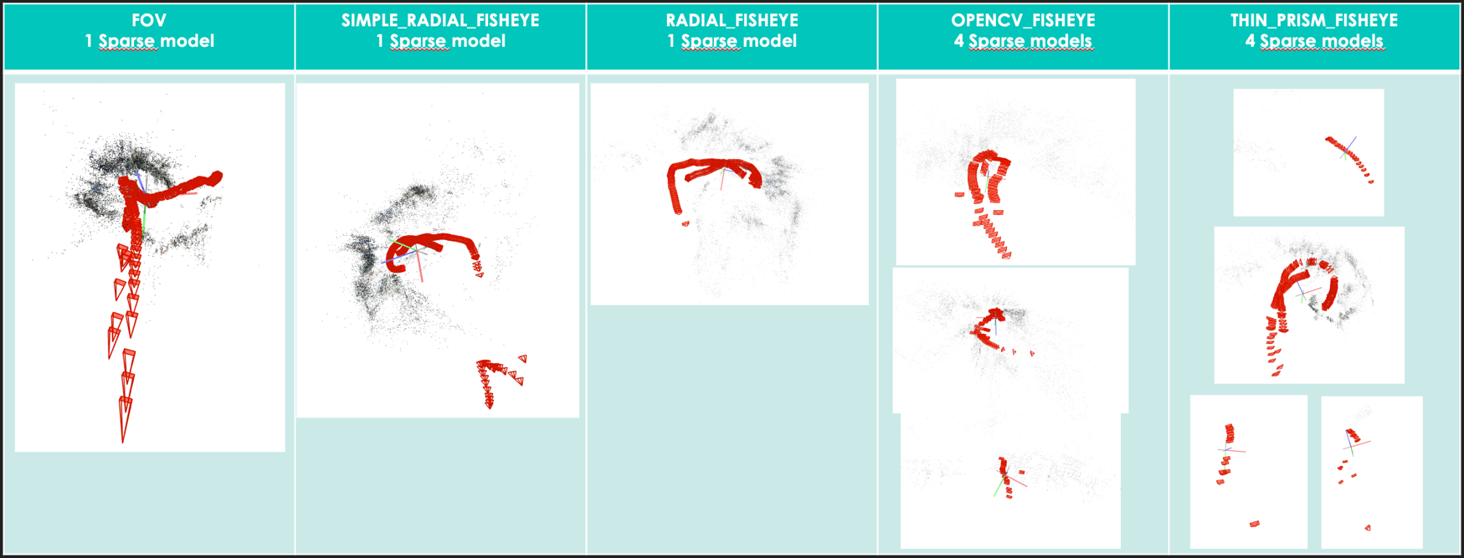

1. Conclusion:

From all the parameters under test, only the camera model seems to give a significant improvement for the SIMPLE_RADIAL_FISHEYE for which only 2 sparse models were created and the frames seemed to be aligned, although not following the correct path. This experiment was not concluding and other parameters need to be taken in account.

## 05/01/20:

1. 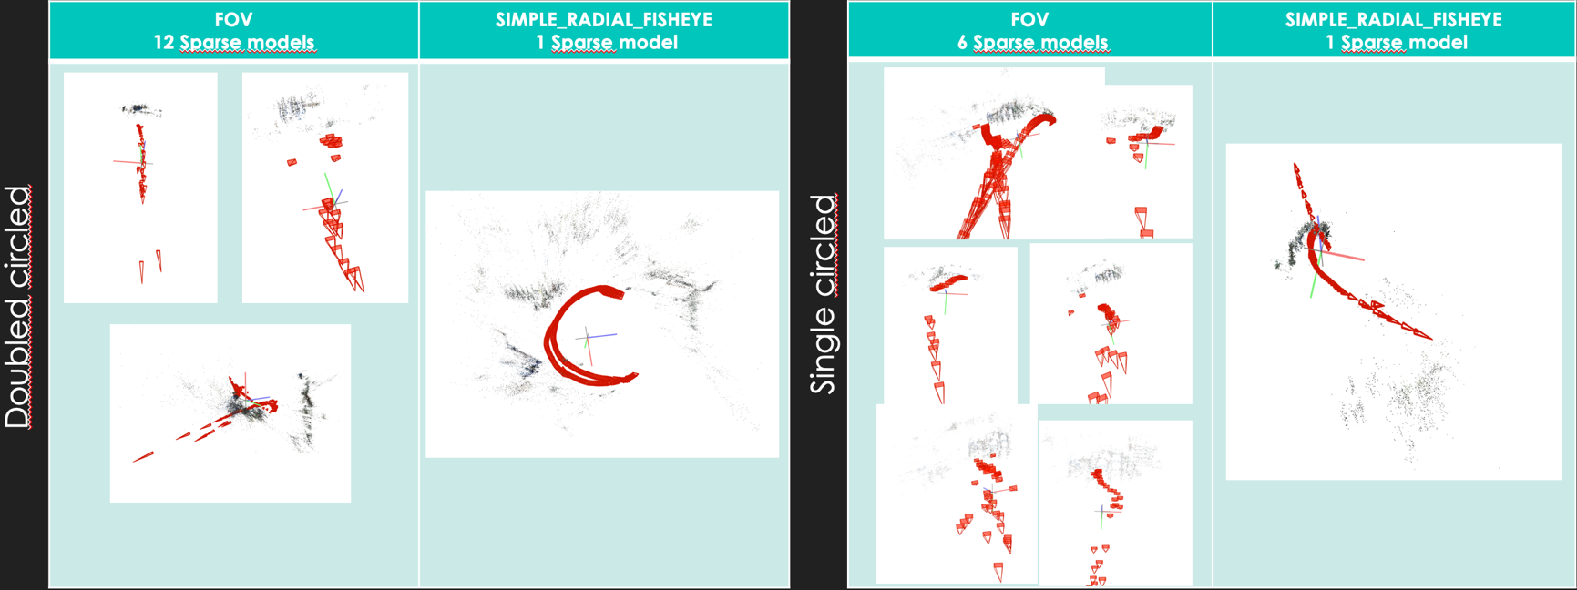1000px wide frames:
2. 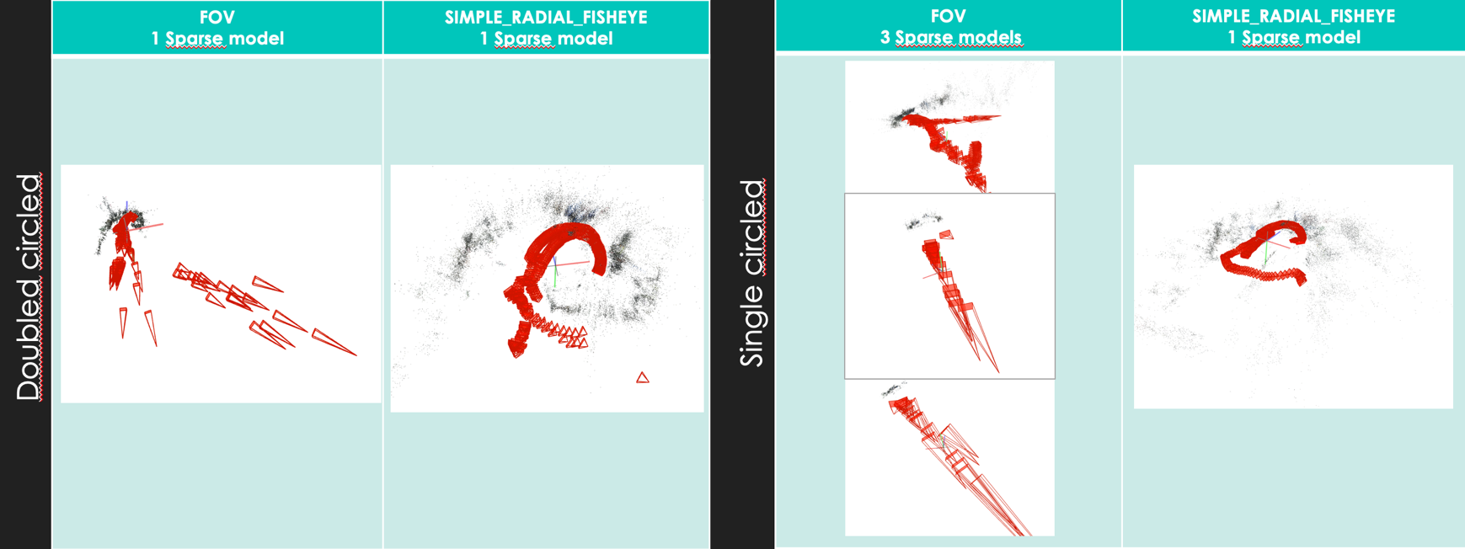2000px wide frames:
3. Conclusion:

The double circled path has slightly improved the SIMPLE_RADIAL_FISHEYE model, however, the results are still wrong.

## 10/01/20:

1. 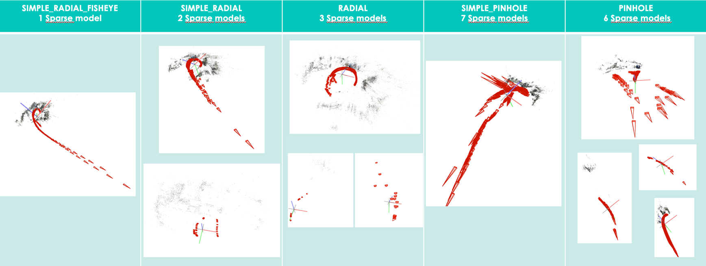10 FPS:
2. 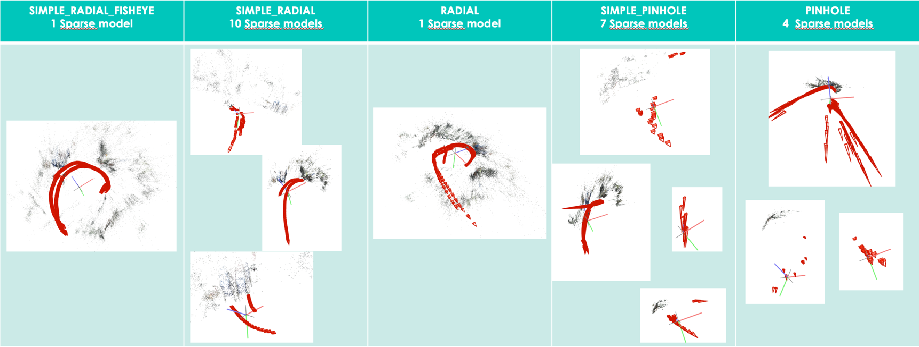20 FPS:
3. Buildots extraction and calibration script:

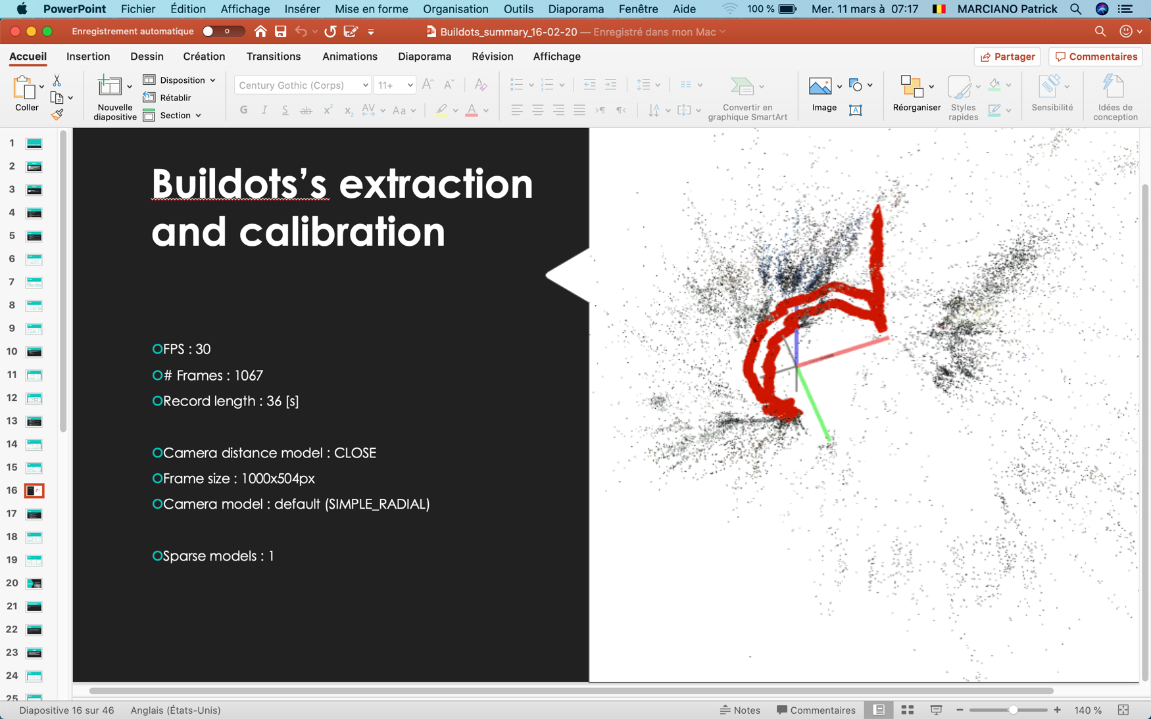

1. Conclusion:

None of the experiments were successful and we did not yet isolate a significant parameter.

## 13/01/20:

1. 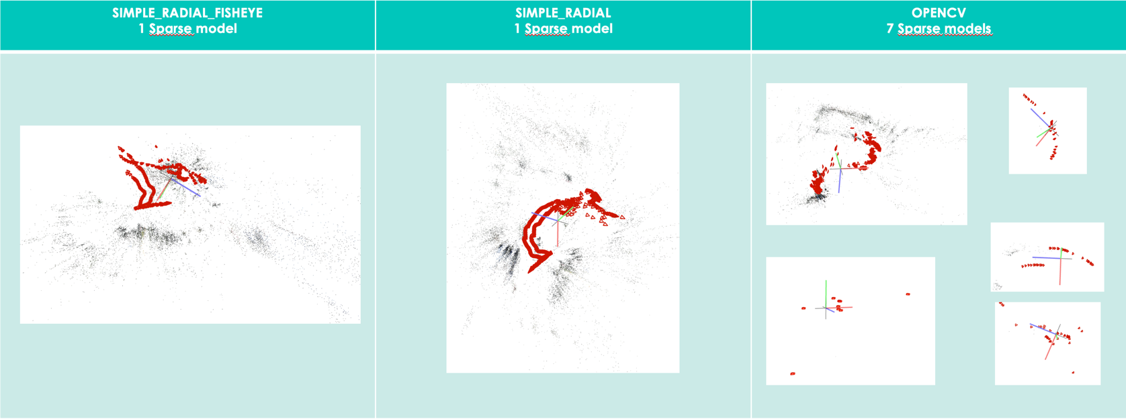1000px wide frames:
2. 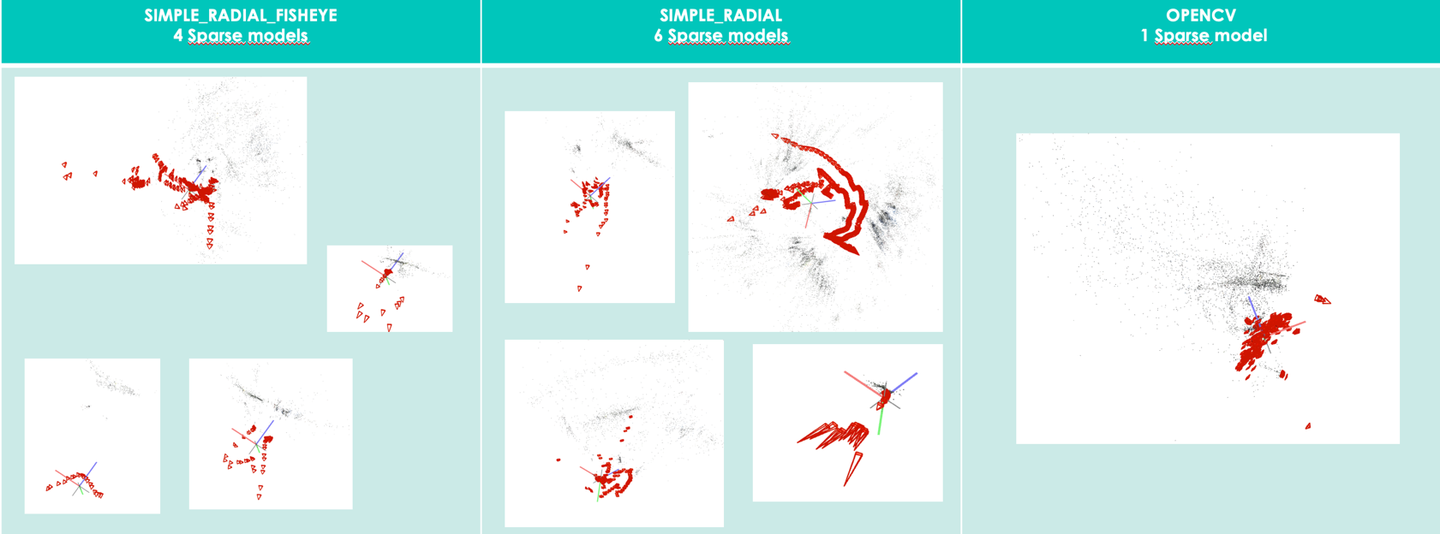2000px wide frames:
3. Conclusion:

The frame size did not improve the results, the calibration may not be suited for such frame size. Untill this point, Colmap has failed to output a correct sparse model. We suspected our videos lack of textures to be the cause for Colmap to fail. We therefore explored the possibility of the camera higher resolution mode (5K and 5.7K). This will effectively increase the number of feature points found and compensate for the poor scenery.

## 20/01/20:

1. 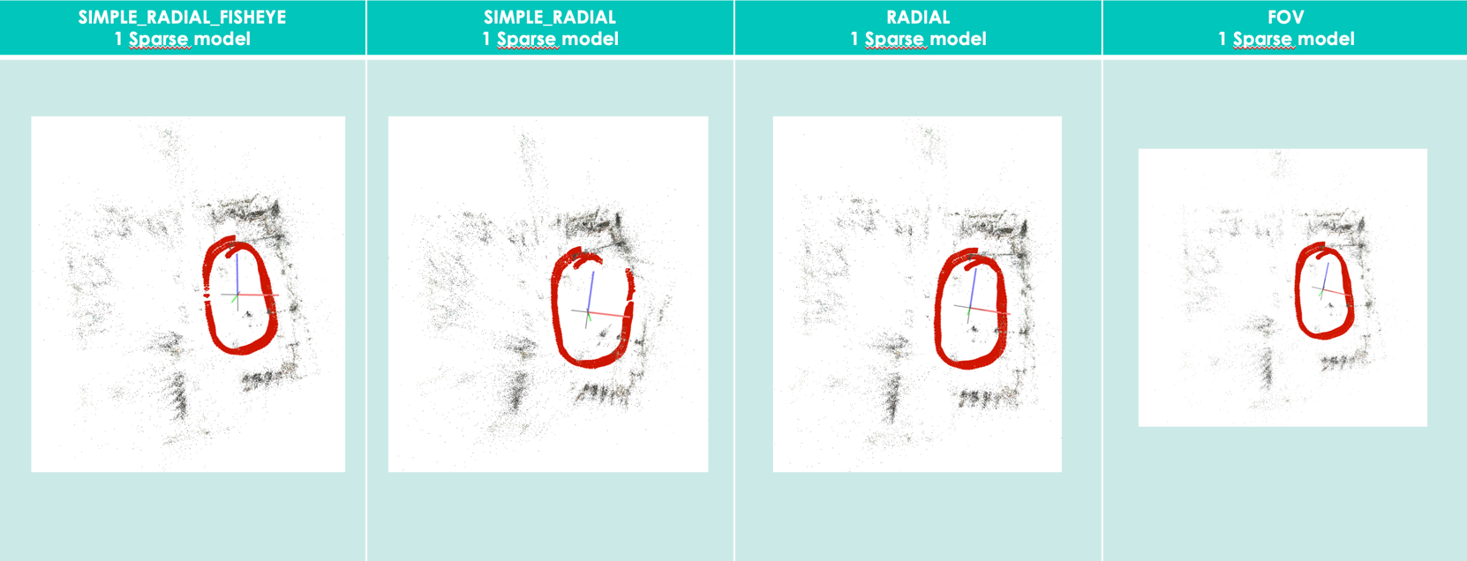10 FPS 5K:
2. 10FPS 5.7K:

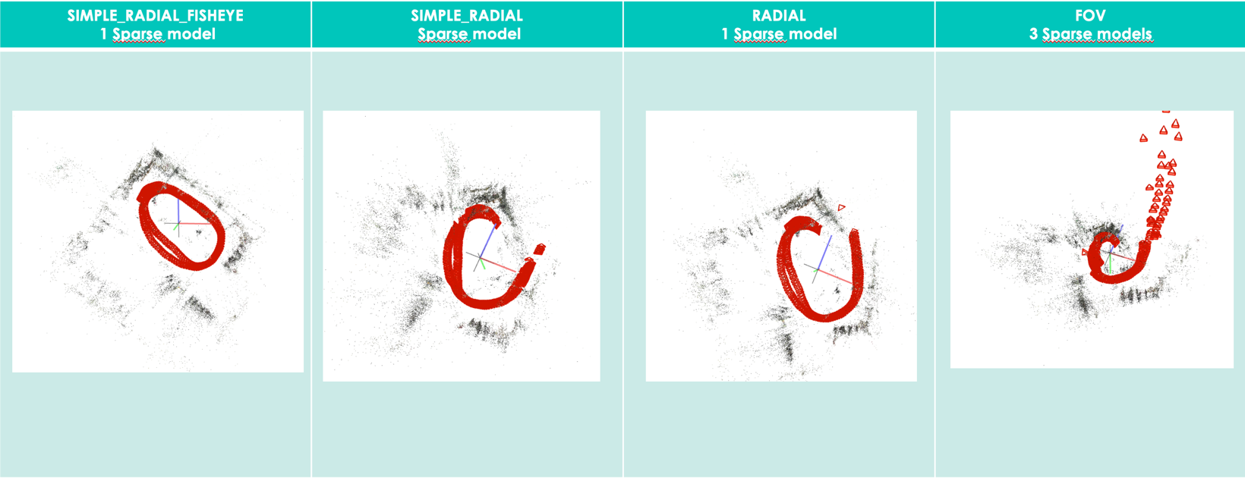

1. 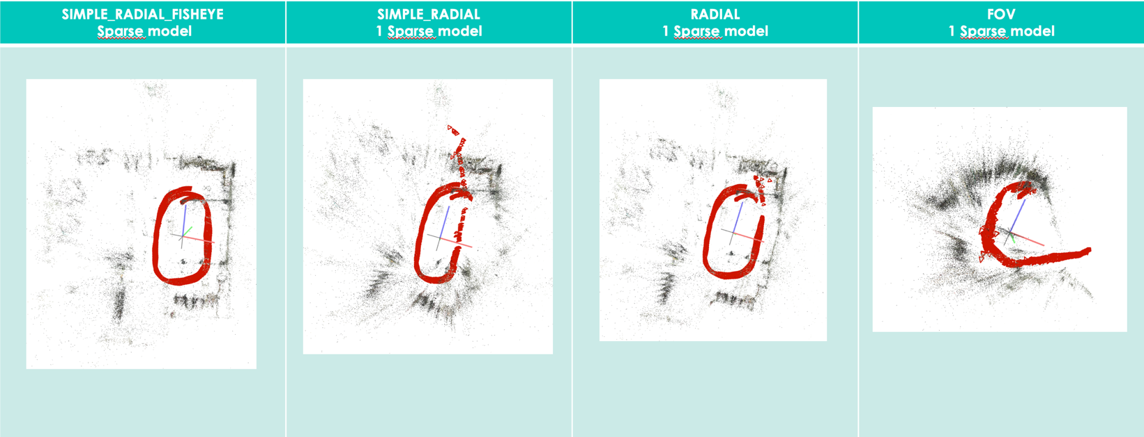20FPS 5K:
2. 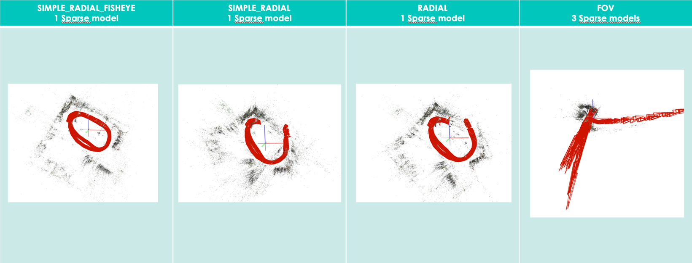20FPS 5.7K:
3. 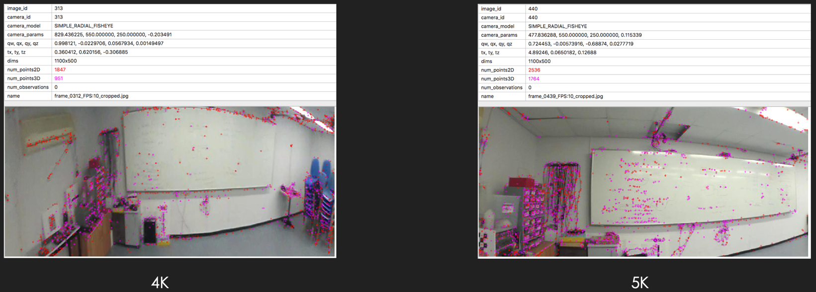Comparison 4K/5K:  
     
     
   We can observe that indeed, increasing the resolution resulted in more feature points being taken. The distortions due to wide field of view are less noticeable with the 5K resolution, this is because we were able to crop each frames further away from their edge with a higher resolution.
4. Conclusion:  
     
   The resolution has been the significant parameter bringing Colmap to output a sparse model following the correct path. The only consistant camera model in this experiment is the SIMPLE_RADIAL_FISHEYE.

## 23/01/20:

1. 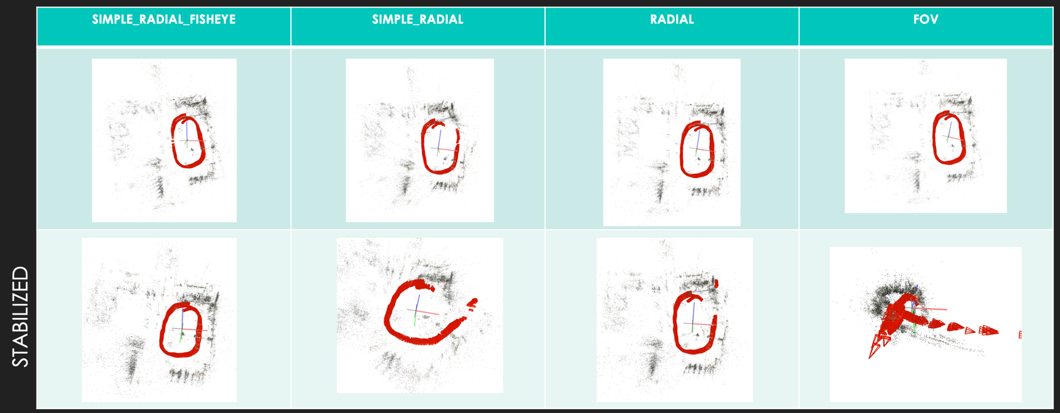5K stabilized:
2. 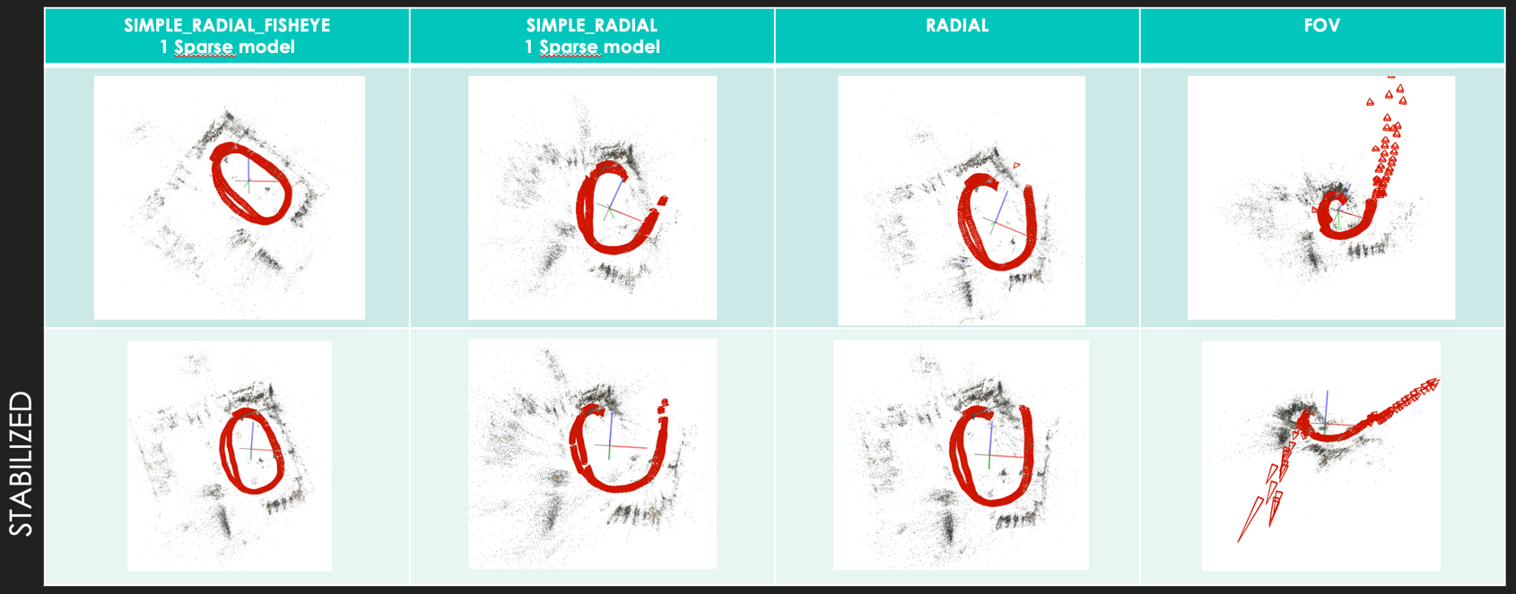5.7K stabilized:
3. Conclusion:  
     
   The stabilization process has modified our dataset both in FPS and frame size, resulting in unexpected results. The next experiment will focus on stabilization using the Garmin Virb edit software for comparison.

## 30/01/20:

1. 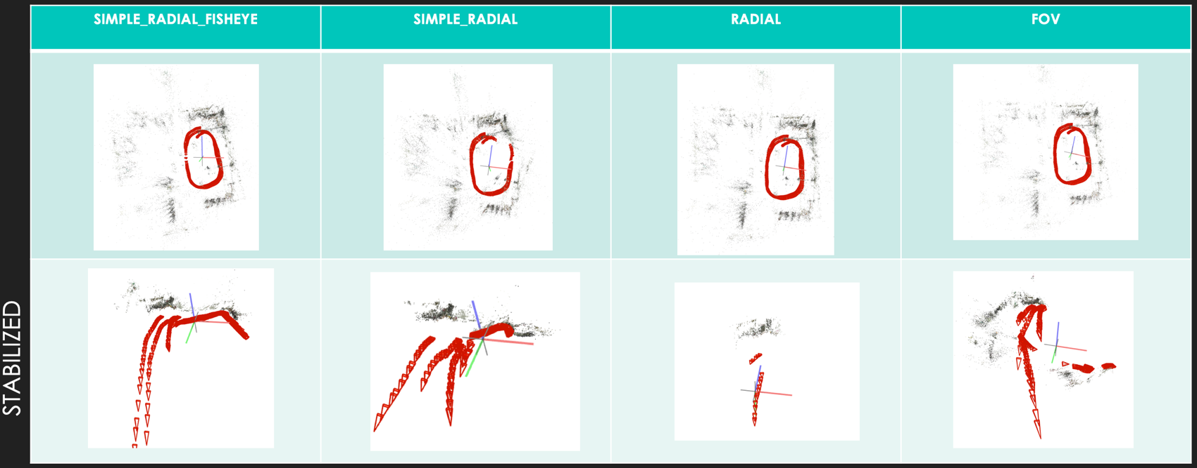5K stabilized:
2. 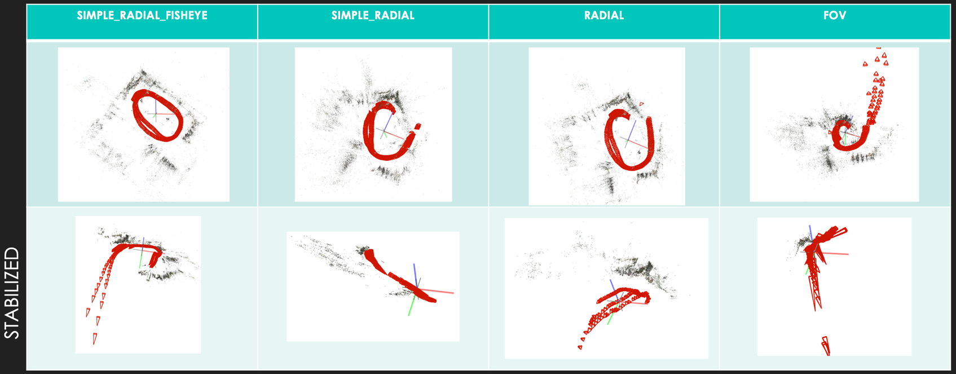5.7K stabilized:
3. 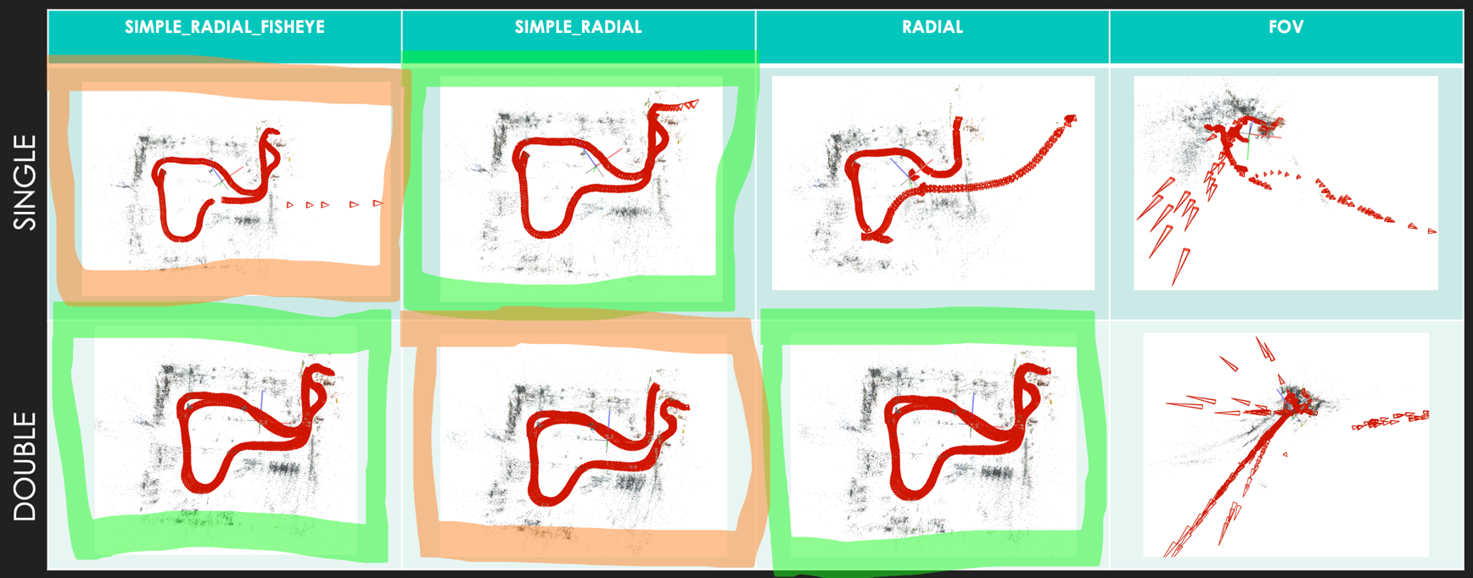Multi room path:
4. 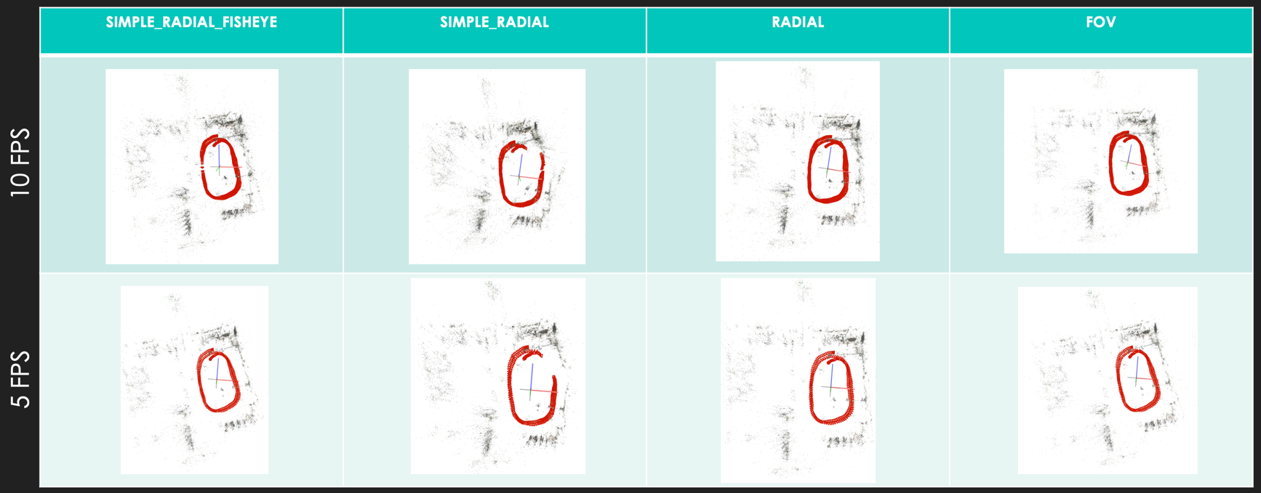5FPS 5K:
5. Conclusion:
   1. Stabilization:   
      In order to use the stabilization tool offered by Garmin Virb edit software, one must import the G-metrix data first, the software then stiches both videos (back and front camera), resulting in additional distortion. Additionally, this process has resulted in more blurry images. This experiment was not concluding.
   2. Multi room path:  
      The multi room path has resulted in correct sparse models for a 5K resolution. Some frames are outside the correct path, this is due to the camera being at a close range from the walls.
   3. 5FPS:  
      The sparse models are following the 10FPS conterparts, both in path and location of wrongly placed frames, we can conclude that lowering the FPS had no destructive effect on the sparse models.

## Conclusion:

From the previous experiments, the factors that have participated in correct sparse models are :

* High resolution recording (5K and 5.7K):  
    
  Enabling more feature point and a bigger area of the frame where the distortion due to FOV lense is not noticeable.
* Sufficient distance from the scene:  
    
  For the frames located too close to the scene, the distortion becomes too high for Colmap to correctly estimate the position. This effect has happened for frames that were taken from a distance between 20-80 [cm] away from the scene.
* Sufficient texture in the scene:  
    
  White walls room and direct light are undesirables.
* Camera models:  
    
  Unless correct calibration, the best camera models that Colmap has to offer are, by order, SIMPLE_RADIAL_FISHEYE, RADIAL and SIMPLE_RADIAL.

# Test example:

For this test, we have limited ourselve to 1 and 2 FPS. Both video (rear and front) were used and their frames were added together.

## Comments on the dataset:

## Frames extraction:

We used the garmin recording size of 2496x2496 and executed the following python script:

import sys

import os

import cv2

_FPS = int(sys.argv[1])

_VIDEO_PATH = sys.argv[2]

_FRAMES_DIR = sys.argv[3]

_OUTPUT_HEIGHT = 2496

_OUTPUT_WIDTH = 2496

def main():

os.makedirs(_FRAMES_DIR, exist_ok=True)

cap = cv2.VideoCapture(_VIDEO_PATH)

frame_idx = -1

while True:

frame_idx += 1

cap.set(cv2.CAP_PROP_POS_MSEC,(frame_idx*(1000/_FPS))) #gets a frame every 1000[ms]/_FPS_

offset_ms = cap.get(cv2.CAP_PROP_POS_MSEC)

print(f"frame_{frame_idx:04}_FPS:{_FPS}.jpg")

ret, cur_frame = cap.read()

if not ret:

return

offset_ms = int(offset_ms)

cur_frame = cv2.resize(cur_frame, (_OUTPUT_WIDTH, _OUTPUT_HEIGHT))

output_path = os.path.join(_FRAMES_DIR, f"frame_{frame_idx:04}_FPS:{_FPS}.jpg")

cv2.imwrite(output_path, cur_frame)

if __name__ == "__main__":

main()

## Frames crop:

We croped 1600x900 out of its center. The last frame size was found following few rules:

* Maximizing the frame size
* Avoiding static scenery (recorder body, recorder gears, mobile phone, …)
* Avoiding edges of the extracted frame which are visually distorted compared to the center.

We executed the following python script and passed the extracted frames folder as argument for _FRAME_DIR:

import sys

import os

import numpy as np

from PIL import Image

_FPS = int(sys.argv[1])

_FRAMES_DIR = sys.argv[2]

_CROP_DIR = sys.argv[3]

_CROP_WIDTH = int(sys. argv[4])

_CROP_HEIGHT = int(sys. argv[5])

def crop_center(pil_img, crop_width, crop_height):

img_width, img_height = pil_img.size

return pil_img.crop(((img_width - crop_width) // 2,

(img_height - crop_height) // 2,

(img_width + crop_width) // 2,

(img_height + crop_height) // 2))

def main():

os.makedirs(_CROP_DIR, exist_ok=True)

fidx = -1

for file in sorted(os.listdir(_FRAMES_DIR)): # sorted() forcing python to keep the frame order, otherwise random

if file.endswith(".jpg"): # avoid working with hidden files if any

fidx += 1

frame = Image.open(os.path.join(_FRAMES_DIR, file))

rect = crop_center(frame, _CROP_WIDTH, _CROP_HEIGHT)

filename = (f"frame_{fidx:04}_FPS:{_FPS}_cropped.jpg")

file_path = os.path.join(_CROP_DIR, filename)

print(filename)

rect.save( file_path )

if __name__ == "__main__":

main()

## Colmap:

With Colmap installed, we executed the following bash script, the first two commands in comment are in case no cuda enabled GPU is available:

DATASET_PATH=$1

#colmap feature_extractor --database_path $DATASET_PATH/database.db --image_path $DATASET_PATH/images --ImageReader.camera_model $2 --SiftExtraction.use_gpu 0

#colmap exhaustive_matcher \

--database_path $DATASET_PATH/database.db --SiftMatching.use_gpu 0

colmap feature_extractor --database_path $DATASET_PATH/database.db --image_path $DATASET_PATH/images --ImageReader.camera_model $2

colmap exhaustive_matcher \

--database_path $DATASET_PATH/database.db

mkdir $DATASET_PATH/sparse

/usr/local/bin/colmap/colmap mapper \

--database_path $DATASET_PATH/database.db \

--image_path $DATASET_PATH/images \

--output_path $DATASET_PATH/sparse

$DATASET_PATH is the path to a folder containing a folder called “images” where all the frames are. In our case, we have copied the content of the cropped frames directory to that images directory.

## Extract and display:

Once you have extracted the results and have them available on a machine with graphic display, you should open Colmap GUI:

1. Create a new project: File--> New project
2. On the project pop up:
   1. Click on open and select your database inside the extracted folder where your results are stored
   2. Click on select and select the images folder inside the same extracted folder
   3. Click on save
3. Open the sparse model: File-->Import Model (not Import Model from…)
4. Select the folder number

After following those step, you should see the sparse model as well as poses. If you click on one pose frame, you can see all the connected feature points and double clicking on it will display the frame corresponding to that pose.

## Comments on the results:

### 1FPS:

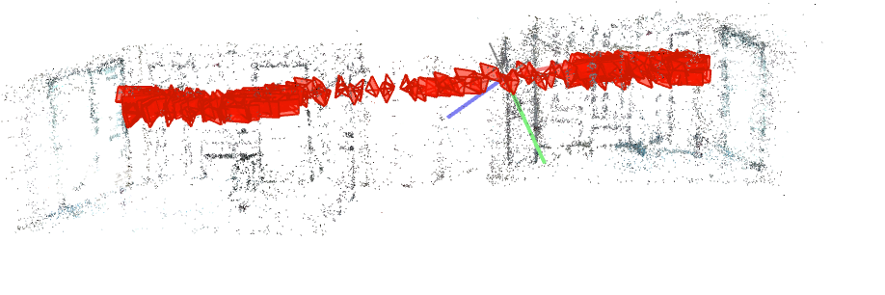

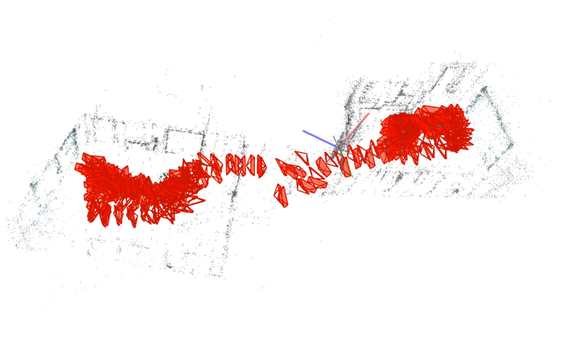

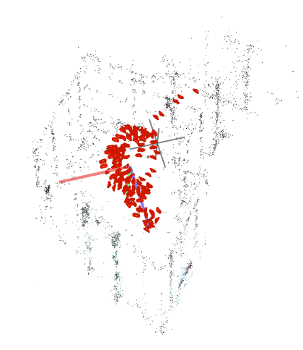

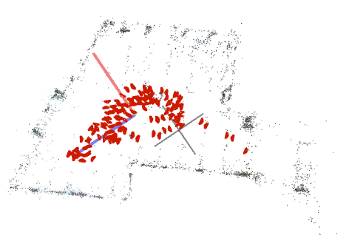

### 2FPS:

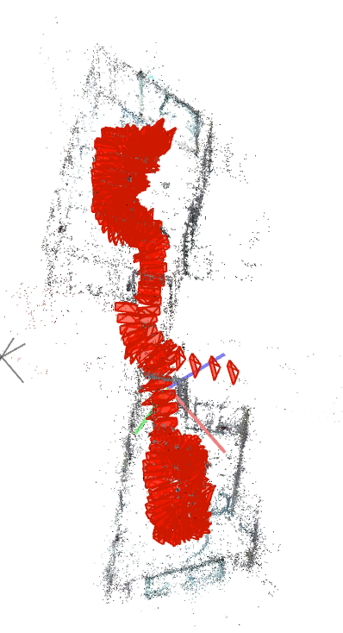

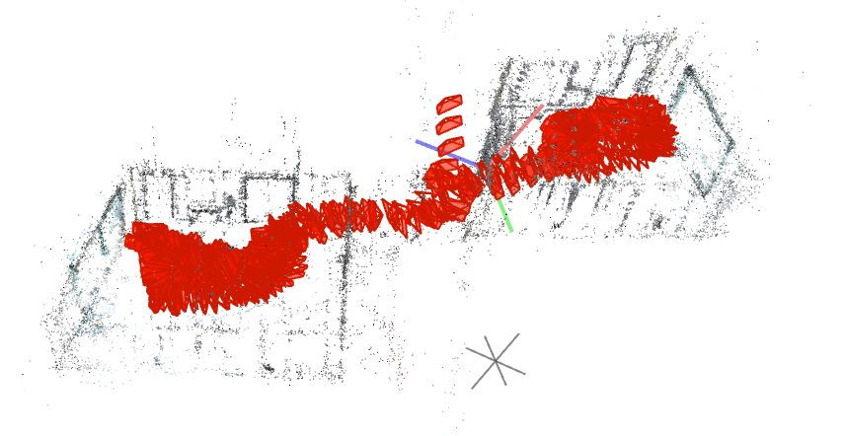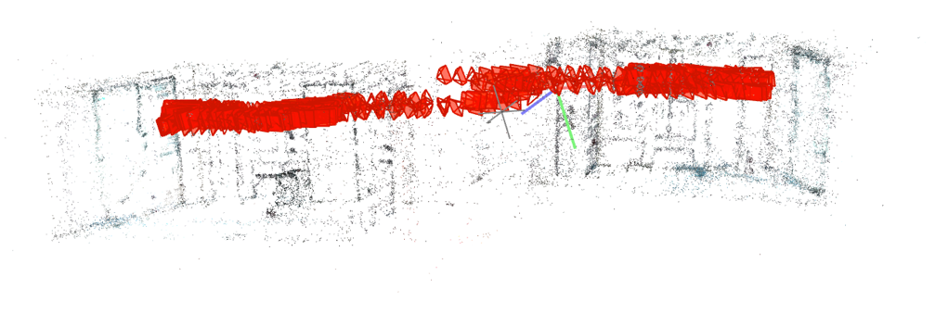

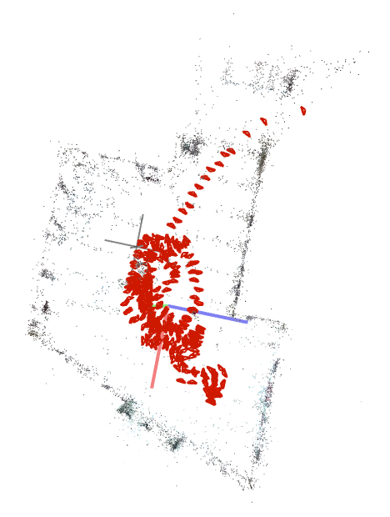

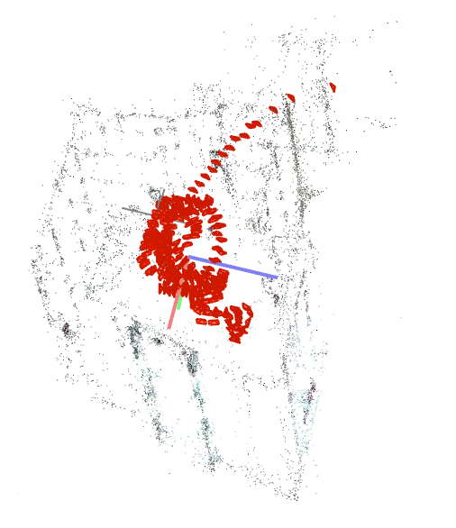

The sparse reconstruction is quite accurate within the rooms. However, due to lowering the FPS, not enough frames are available to makes the transition in between rooms appearing on the sparse model. Out of the 3 rooms recorded, only 2 are connected (sparse model 1) and one is standing by istelf (sparse model 2).

In order to get the last missing transistion and more feature points for the hallways, one need to increase the FPS. A further version of this documment will explore this.

# Reproducing the experiments:

The environment:

In order to reproduce the experiments without dependencies issues, a ready made docker image was created.

This image has Colmap 3.5, Python 3.7 and Jupyter notebook installed.